1)write a c program to print Fibonacci series

#include<stdio.h>

int main()

{

int n1=0,n2=1,n3,i,number;

printf("Enter the number of elements:");

scanf("%d",&number);

printf("\n %d %d",n1,n2);

for(i=2;i<number;i++)

{

n3=n1+n2;

printf("%d",n3);

n1=n2;

n2=n3;

}

return 0;

}

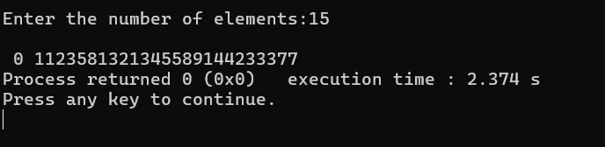

2)write a c program to print factorial of a number

#include<stdio.h>

int main()

{

int i,fact=1,number;

printf("enter a number:");

scanf("%d",&number);

for(i=1;i<=number;i++)

{

fact=fact\*i;

}

printf("Factorial of %d is: %d",number,fact);

return 0;

}

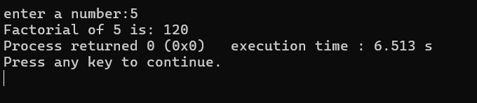

3)write a program a[20],take the input from user and print all the elements pf a[20] with their index values

#include<stdio.h>

int main()

{

int a[20];

int i;

printf("Enter 20 elements : \n");

for(i=0;i<20;i++)

{

printf("enter elements %d : ",i);

scanf("%d",&a[i]);

}

printf("\n elements of a[20]with index values:");

for(i=0;i<20;i++)

{

printf("a[%d] = %d\n",i,a[i]);

}

return 0;

}

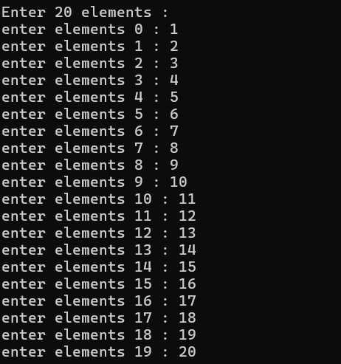

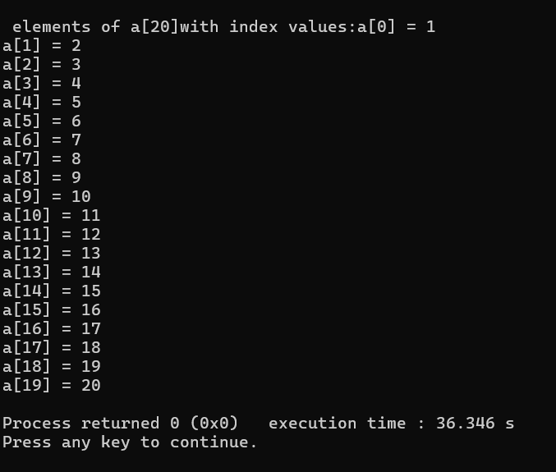

4)write a program to delete a particular elements from an array

#include<stdio.h>

int main()

{

int a[20],i,j;

printf("enter the elements of the array of 20 :\n");

for(i=0;i<20;i++)

{

scanf("%d",&a[i]);

}

printf("\n enter the index of value which is to be deleted : ");

scanf("%d",&j);

a[j]=0;

printf("\n printing the elements of the array after deleting the element ");

for(i=0;i<20;i++)

{

printf("%d",a[i]);

}

return 0;

}

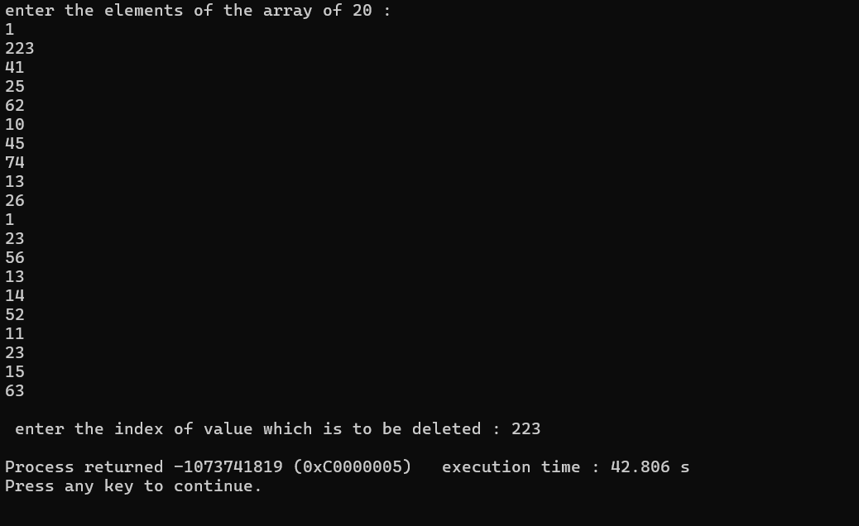

5)find if there r any duplicates in a[20]

#include<stdio.h>

int main()

{

int a[20],i,j;

printf("enter the element of the array of 20 : \n ");

for(i=0;i<20;i++)

{

scanf("%d",&a[i]);

}

printf("\n printing index values of duplicate elements:\n");

for(i=0;i<20;i++)

{

for(j=i+1;j<20;j++)

{

if(a[i]==a[j])

{

printf("%d and %d \n",i,j);

}

}

}

}

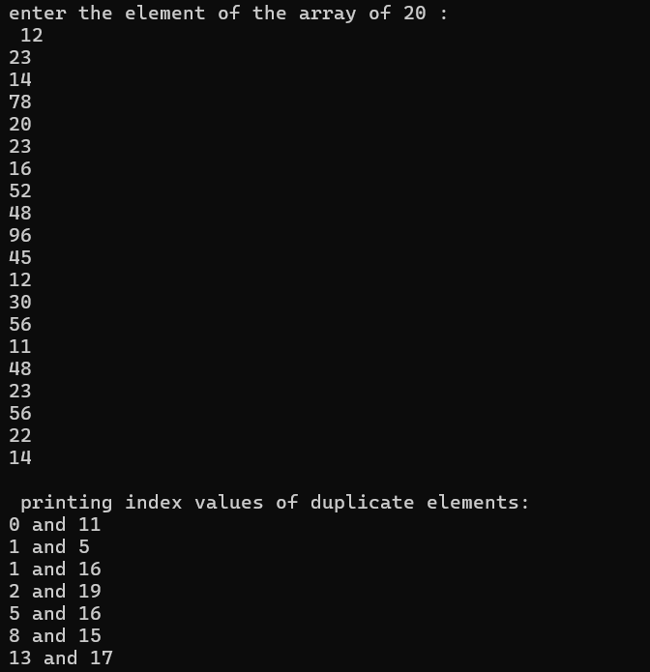

6)write a program to search [10] from a[20]

#include<stdio.h>

int main()

{

int a[20];

int i,num;

int found=0;

printf("Enter 20 elements : \n");

for(i=0;i<20;i++)

{

printf("enter elements %d : ",i);

scanf("%d",&a[i]);

}

printf("enter the elements to search:");

scanf("%d",num);

for(i=0;i<10;i++)

{

if(a[i] == num )

{

found =1;

break;

}

}

if(found)

{

printf("element %d found in a[10]\n",num);

}

else

{

printf("element %d not found in a[10] \n",num);

}

return 0;

}

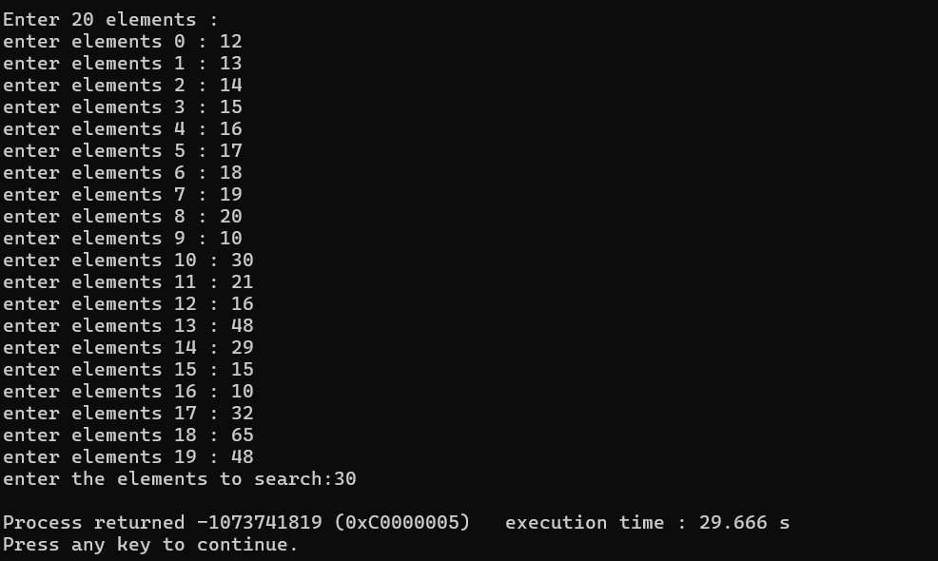

7)calendar

#include <stdio.h>

#include <conio.h>

#include <stdlib.h>

main ()

{

int choice, a, b, result=0,y, rem;

start:

printf("\nWelcome to my calculator\n");

printf("\n 1. Add numbers");

printf("\n 2. Subtract numbers");

printf("\n 3. Multiply numbers");

printf("\n 4. Divide Numbers");

printf("\n 5. Exit");

printf("\nEnter your choice:: ");

scanf("%d", &choice);

switch(choice)

{

case 1:

{

add:

printf(" \*\*\* Addition \*\*\*\*");

printf("\nEnter first number::");

scanf("%d", &a);

printf("\nEnter Second number::");

scanf("%d", &b);

result = a+b;

printf("\nAddition is :: %d", result);

printf("\n Do you want to continue ? (0/1)?\n");

scanf("%d",&y);

if (y==1)

{

system("cls");

goto add;

}

else

goto start;

break;

}

case 2:

{

sub:

printf(" \*\*\* Subtraction \*\*\*\*");

printf("\nEnter first number::");

scanf("%d", &a);

printf("\nEnter Second number::");

scanf("%d", &b);

result = a-b;

printf("\nResult is :: %d", result);

printf("\n Do you want to continue ? (0/1)?\n");

scanf("%d",&y);

if (y==1)

{

system("cls");

goto sub;

}

else

goto start;

break;

}

case 3:

{

mul:

printf(" \*\*\* Multiplication \*\*\*\*");

printf("\nEnter first number::");

scanf("%d", &a);

printf("\nEnter Second number::");

scanf("%d", &b);

result = a\*b;

printf("\nResult is :: %d", result);

printf("\n Do you want to continue ? (0/1)?\n");

scanf("%d",&y);

if (y==1)

{

system("cls");

goto mul;

}

else

goto start;

break;

}

case 4:

{

div:

printf(" \*\*\* Division \*\*\*\*");

printf(" \n\*\* Divisor must not be Zero \*\*");

printf("\nEnter first number::");

scanf("%d", &a);

printf("\nEnter Second number::");

scanf("%d", &b);

if (b==0)

{

printf(" Its not possible");

goto start;

}

else

{

result = a/b;

printf("\nQoutient is :: %d", result);

rem = a%b;

printf("\nRemainder is :: %d", rem);

}

printf("\n Do you want to continue ? (0/1)?\n");

scanf("%d",&y);

if (y==1)

{

system("cls");

goto div;

}

else

goto start;

break;

}

default:

printf("Bye");

}

}

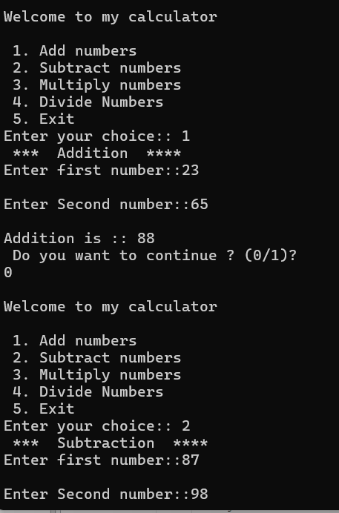

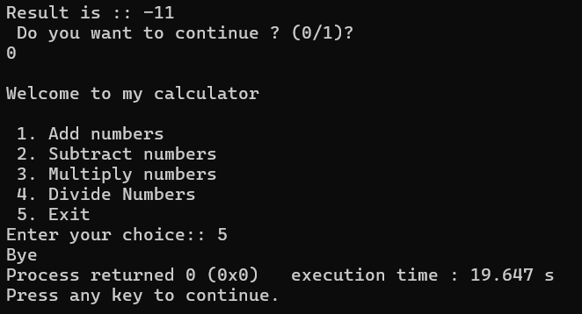

8)write a program to print starts .

#include<stdio.h>

#include<conio.h>

void main()

{

int i,j,ns=0;

system ("cls");

printf("\n Enter the number rows for stars::");

scanf("%d",&ns);

for(i=1;i<=ns;i++)

{

for(j=1;j<=i;j++)

{

printf("\*");

printf("\t");

}

printf("\n");

}

}

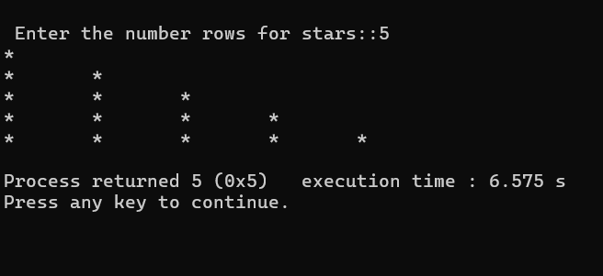

8)matrix multiplication

#include<stdio.h>

void main()

{

system ("cls");

int i,j,k,r,a[2][2],b[2][2], c[2][2];

printf("\n Matrix Multiplication [2][2] \n ");

printf("Enter first matrix::");

for(i=0;i<2;i++)

{

for(j=0;j<2;j++)

{

scanf("%d",&a[i][j]);

}

printf("\n");

}

printf("Enter second matrix::");

for(i=0;i<2;i++)

{

for(j=0;j<2;j++)

{

scanf("%d",&b[i][j]);

}

printf("\n");

}

printf("The matrix a[][] and b[][] are :: \n");

for(i=0;i<2;i++)

{

for(j=0;j<2;j++)

{

printf("%d",a[i][j]);

}

printf("\n");

}

printf("multiplication is :: \n");

for(i=0;i<2;i++)

{

for(j=0;j<2;j++)

{

c[i][j]=0;

for (k=0;k<2;k++)

{

c[i][j] = c[i][j] + ( a[i][k] \* b[k][j]);

}

printf("%d\t",c[i][j]);

}

}

}

